MODULE 2 ASSIGNMENT

Environment Variable
1. How can you ensure that the mv command (used for renaming a file) always asks for permission before overwriting an existing destination file ?[ Hint : use alias command ]
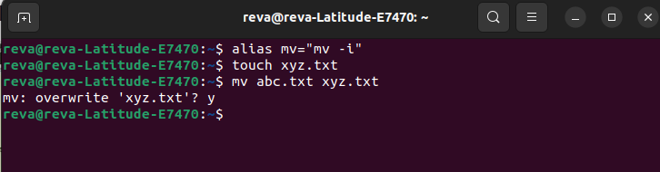

Basics Of System Administration in Linux
1) Create a new user account and home directory called "Duck"
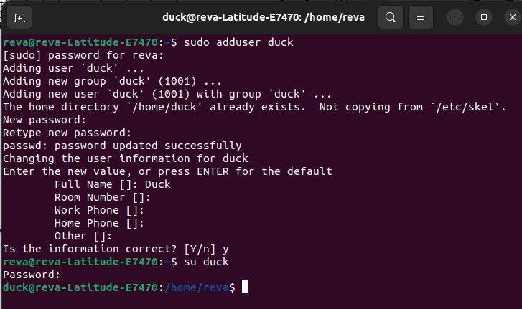

2) Set the user account "Duck's" expirey date as 07 - 01 – 2015
3) find the id of the user account "Duck"
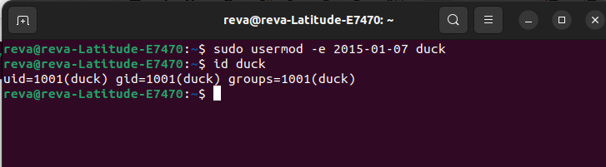
4) Type df and du commands and see the output on your terminal.
df-It provides information about the total disk space, used and available space, and the filesystem type for each mounted device or partition.
du-It provides information about the total size occupied by files and subdirectories within a specified directory or a list of directories.
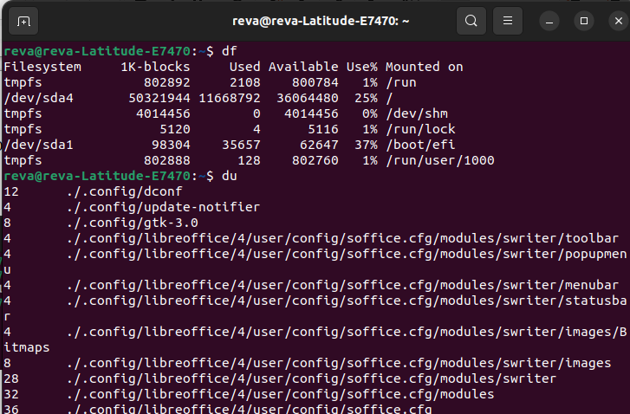
5) Type this command on the terminal and see the output : du -ch *.txt
The command du -ch *.txt in Linux checks how much space is used by files in the current folder that have a ".txt" extension.
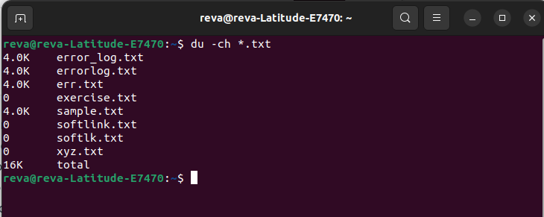
6) Delete the user account "Duck" permanently along with its home folder.
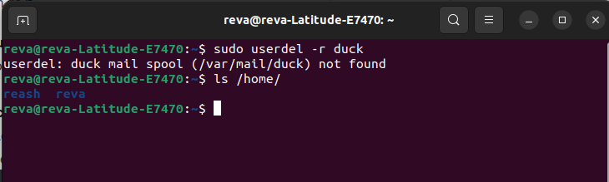
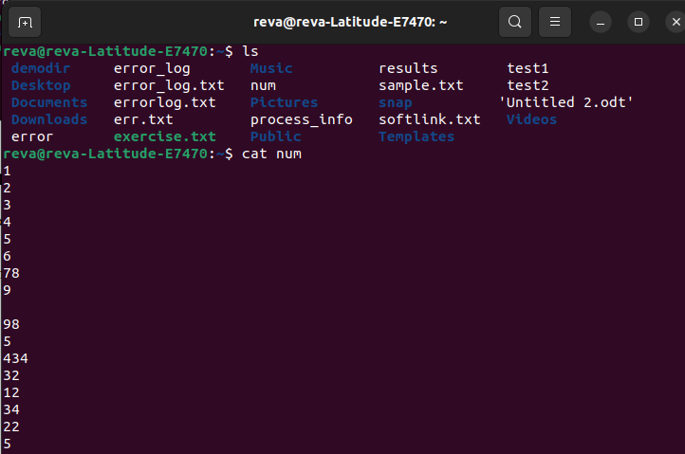
Simple Filters
TOPIC:1 HEAD
Assingment1

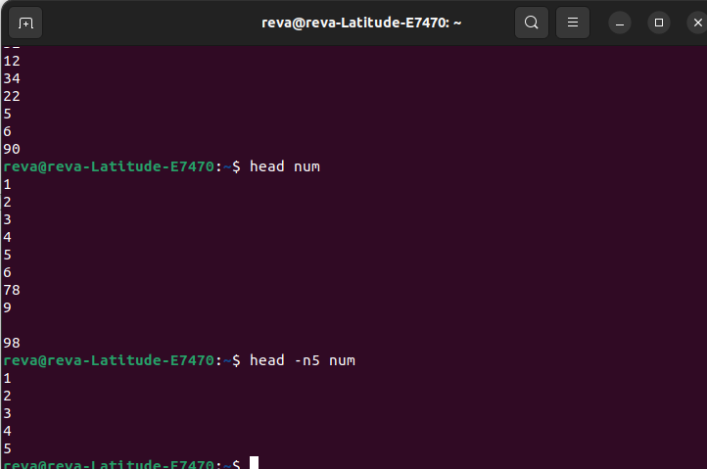
Assignment 2
The /etc/passwd file is essential for user account management and is used during the login process to determine user privileges, home directories, and default shells.
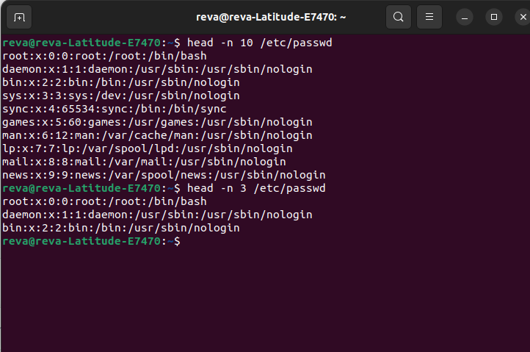
TOPIC: TAIL
Assignment 1
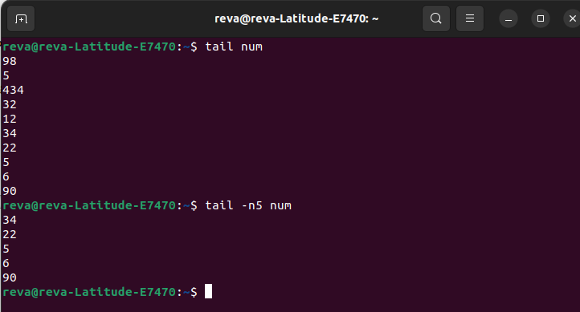
Assignment 2
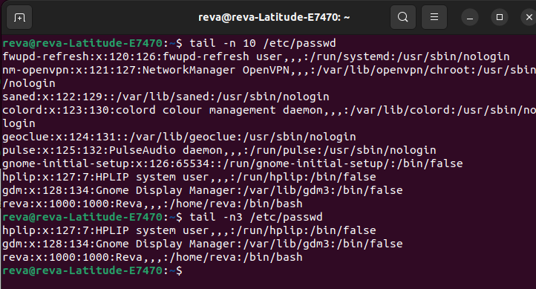
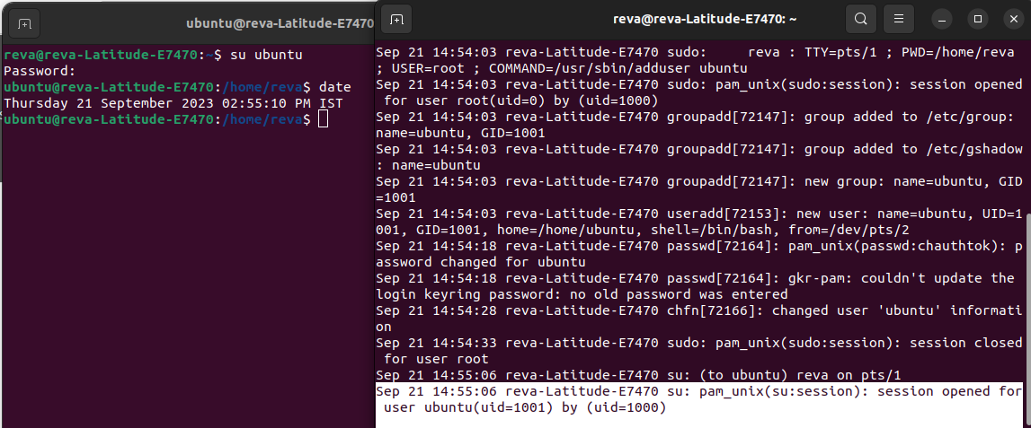
TOPIC: SORT
Assignment 1
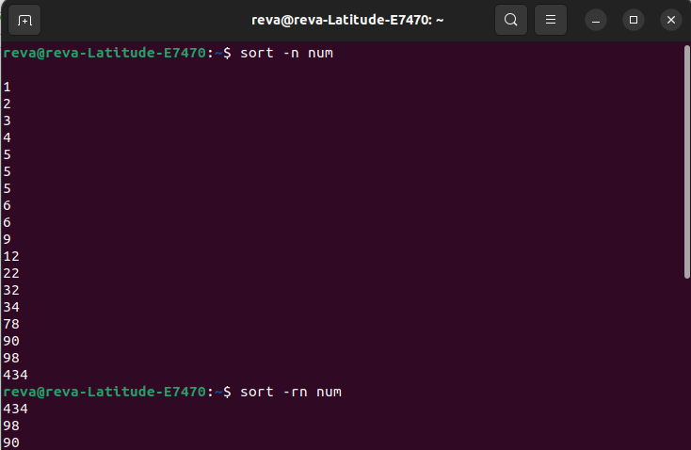

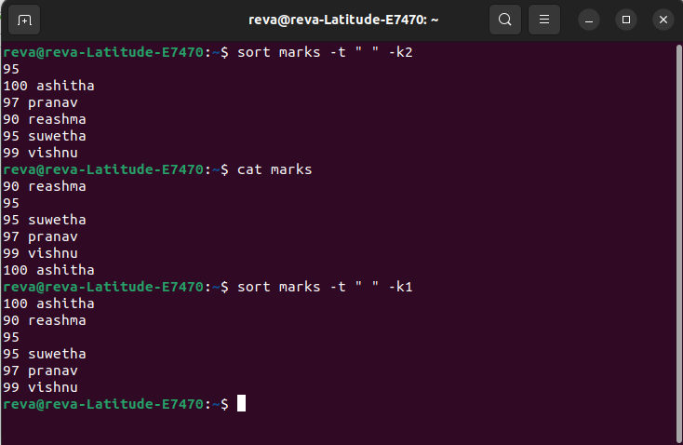
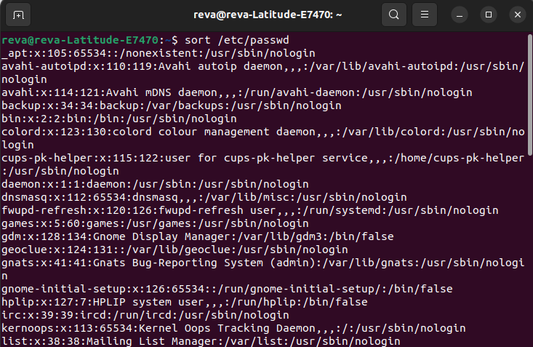

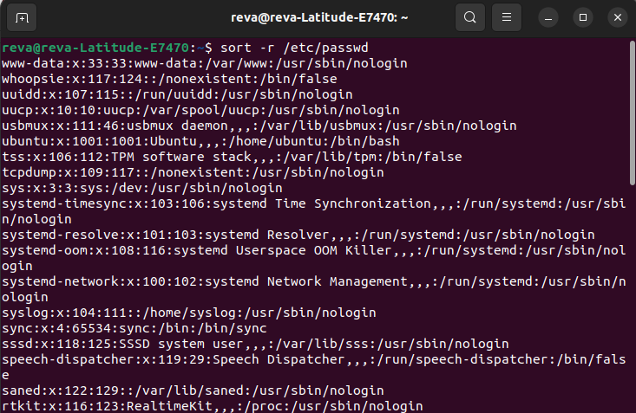

TOPIC: CUT
Assignment
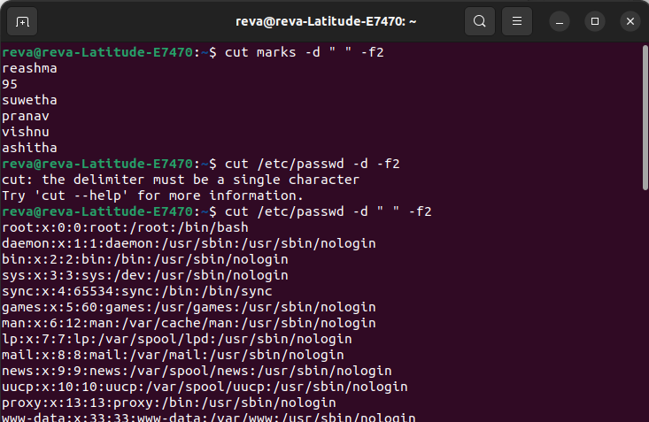
TOPIC: PASTE
Assignment 1
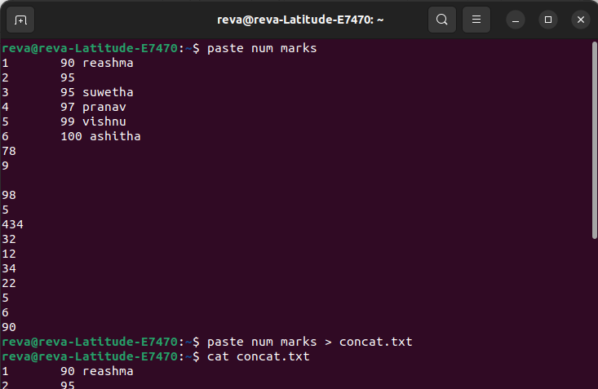

Assignment 2
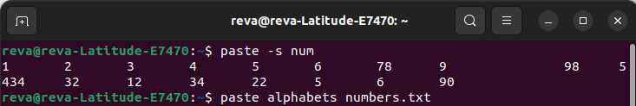
The grep command
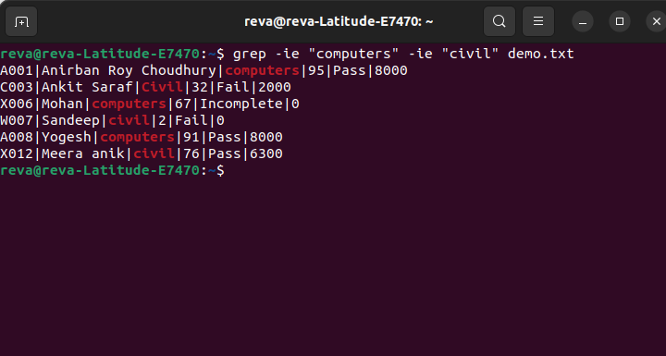
More on grep command
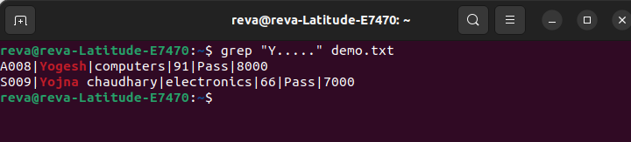
Sed command
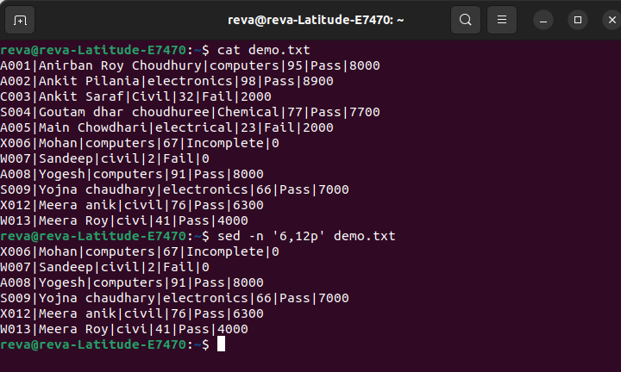
More on sed command
